**Sprint 2 Retrospective**

**Product:** SquadUp

**Team:** The Big Ballers

**Revision date:** 7/17/2018

**Actions to stop doing:**

Stop overestimating how much work we can do in a week with numerous classes and obligations.

No more changing technologies this far into the project. The Gatsby technology change hurt the hours for learning the new technology and how it integrates into the project.

**Actions to start doing:**

Keeping the communication that we have in person and in the remote pipeline the same consistency. It is very difficult to always be in a work environment outside of the project jam sessions and class.   
  
Making sure that we are not underestimating the hours that we will be spending on the tasks given. Sprint 2 has been a lot better in terms of actual hours vs. estimated hours. We still overestimated by a little bit.

**Actions to keep doing:**

Keeping up to date on our documentation to keep all members up to date on how the software parts coincide with one another. We should keep our scrum meeting times in the afternoon because this accommodates all the members schedules.

Keep the workflow in our project jams the same as it has been. Take 3 hours on our meeting days to work together in a group. After these meetings we will keep holding the scrum sessions.

Keep the increased communication levels. This helps with productivity and troubleshooting if team members need help with a certain roadblock on their tasks.

The pair programming that we did in sprint 2 was very effective and helped all team members with their task progress.

**Work completed/not completed:**

The user stories completed are as follows:  
  
1. As a developer, I want to connect the server with the client so data can be passed back and forth.

The user story that was not completed:

2. As a user, I want to be able to view the map of all the parks and games available in my local area. (Test case: UCSC fields and outside basketball courts).

**Work completion rate:**  
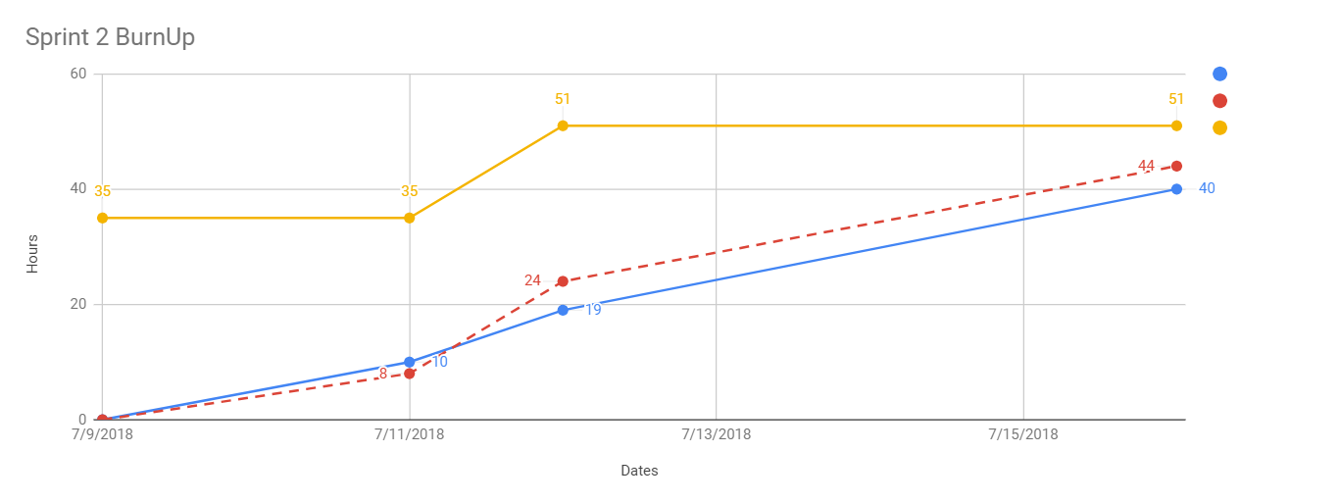After assessing the tasks for sprint 2, we completed 1 user stories and had one pushed back to the product backlog.

The burnup chart shown has a key, blue being estimated hours completed, red being the actual hours completed, and yellow being the total estimated hours. Just by looking at the chart it is obvious that we underestimated the hours necessary to complete the tasks for user stories 1 and 2. The amount of actual hours was 44 hours, and the estimated total hours was 40 hours. This is a lot closer of an estimate than our previous sprint 1 estimates. We are over by 4 working hours. This shows that the underestimate in the tasks might have been caused by learning a completely new technologies. We will have to compensate for this mistake in future sprints. The average user story completed per day is 0.14 stories, and the average ideal hours completed per day is 5.71 ideal hours.

The cumulative chart since sprint 1:

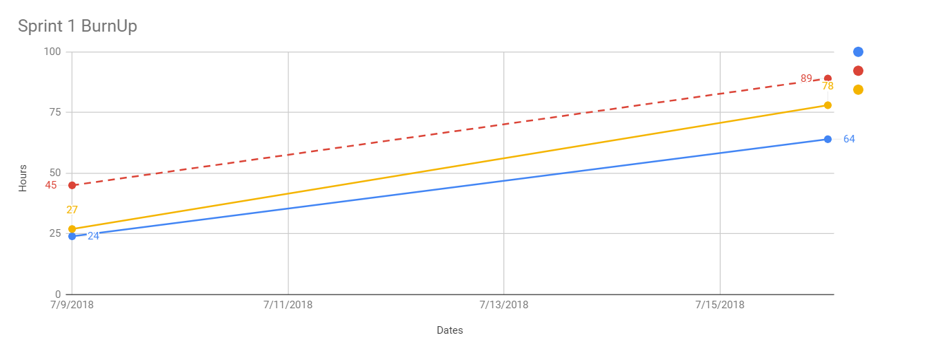

As you can see, we underestimated heavily, because the actual hours worked is greater than the ideal hours and the ideal total hours.